Press release from AECO - Association of Arctic Expedition Cruise Operators (for immediate release):

Tour operators’ efforts to tackle Arctic marine litter highlighted in new video

April 29, 2021, Tromsø, Norway

The Arctic expedition cruise industry has vowed to leave Arctic beaches cleaner than they find them. In addition, they are working to address the problem at its source. The industry’s efforts to combat marine plastic pollution is presented in a new information video.

“Leave no trace” is a guiding principle for considerate tourism in ecologically sensitive areas. The members of the Association of Arctic Expedition Cruise Operators (AECO) have decided to take this ethic one step further by cleaning up beach litter in the areas that they visit. These clean-ups are part of a greater effort to beat marine plastic pollution through education and new solutions to reduce the use of single-use items on passenger vessels.
According to Melissa Nacke, AECO’s environmental specialist, the industry aims to be part of the solution to this global problem. A new video explains how the association is working to address marine litter though their Clean Seas Project.
“Our members sail to remote locations where travelers go to experience the unique nature and rich culture. They see first-hand how litter transported by ocean currents can impact the local environment. Inspired to act, thousands of passengers and staff volunteer in Arctic beach cleanups every year. Our members visit the same landing sites year after year, and it’s clear that these cleanups make a difference. At the beginning of the season, a beach may be littered with everything from fishing nets to plastic containers that have drifted there over the winter. At the end of the season, some beaches been cleaned so thoroughly that they are completely free of visible debris,” says Nacke.
While cruise ships are generally not a source of marine litter in the Arctic, the association’s members are also reducing their plastic footprint by rethinking how things are done on their ships.
“This project helps our members to carefully consider the choices they make when selecting the products that they use on board. All of our surveyed members have implemented sustainable alternatives such as refillable bottles, plastic-free buffets, and biodegradable packaging. Educating guests is also an important part of the project. The combination of seeing the sustainable choices made on the ship and cleaning up Arctic beaches sends a powerful message to travelers,” says Nacke.
In addition to taking action on ships and Arctic beaches, AECO collaborates with researchers and local partners to raise awareness and build the knowledge needed to confront this global problem.

Suggested illustration photos:
High resolution illustration images can be downloaded here:
https://www.dropbox.com/sh/317iu5144towbrm/AAAHP9aNwWUy0uK9NOHlX66Ta?dl=0
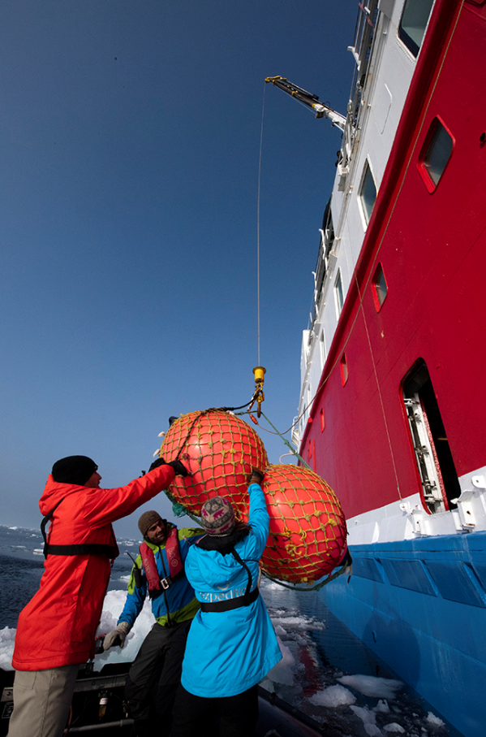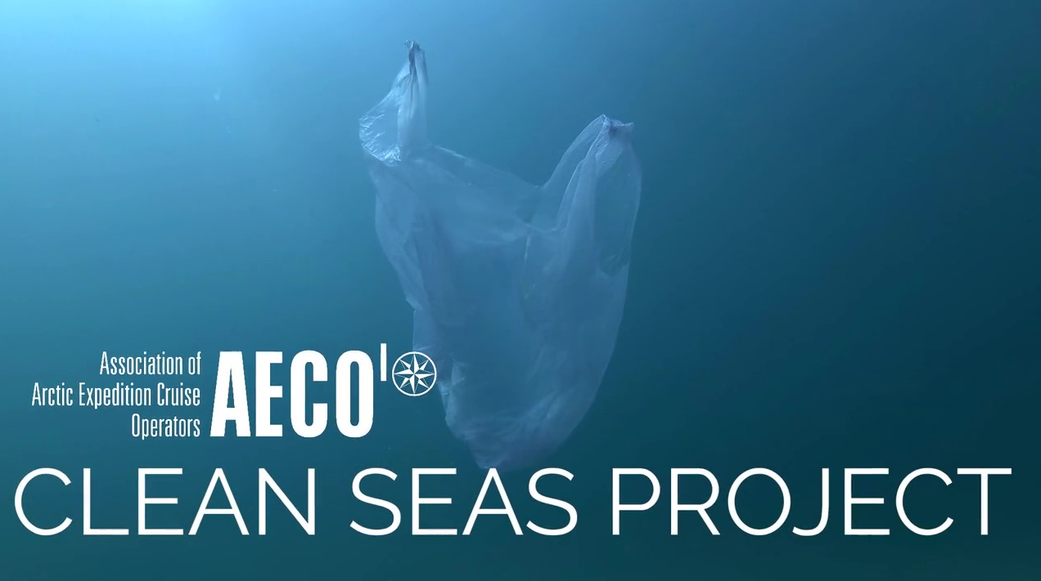
The information video is available here: https://vimeo.com/aecocruise/cleanseas
Contacts
Edda Falk, communications manager, AECO - Association of Arctic Expedition Cruise Operators edda@aeco.no | Cell: +47 476 32 550 | www.aeco.no
AECO - Association of Arctic Expedition Cruise Operators
The Association of Arctic Expedition Cruise Operators is an international organization for expedition cruise operators and associates in the Arctic, dedicated to managing environmentally friendly, safe and considerate cruise tourism. With around 70 international members, including 47 vessel operators, owners and management, AECO represent the great majority of these operations in the Arctic. AECO works to ensure that expedition cruises and tourism in the Arctic is carried out with the utmost consideration for the vulnerable, natural environment, local cultures and cultural remains, as well as the challenging safety hazards at sea and on land.
Website: www.aeco.no.

AECO´s Clean Seas Project
The Association of Arctic Expedition Cruise Operators (AECO) is working to combat marine plastic pollution. As part of these efforts, AECO is working to drastically cut back on single-use plastics on Arctic expedition cruise vessels, as well as enhance cruise passengers’ involvement in regular beach cleanups. AECO is also focus on educating passengers, staff and the public on what can be done to prevent marine plastic pollution. The major funding sources for this project are Svalbard Environmental Protection Fund, the Norwegian Environment Agency and the Norwegian Retailers’ Environment Fund.
Website: https://www.aeco.no/clean-seas/

